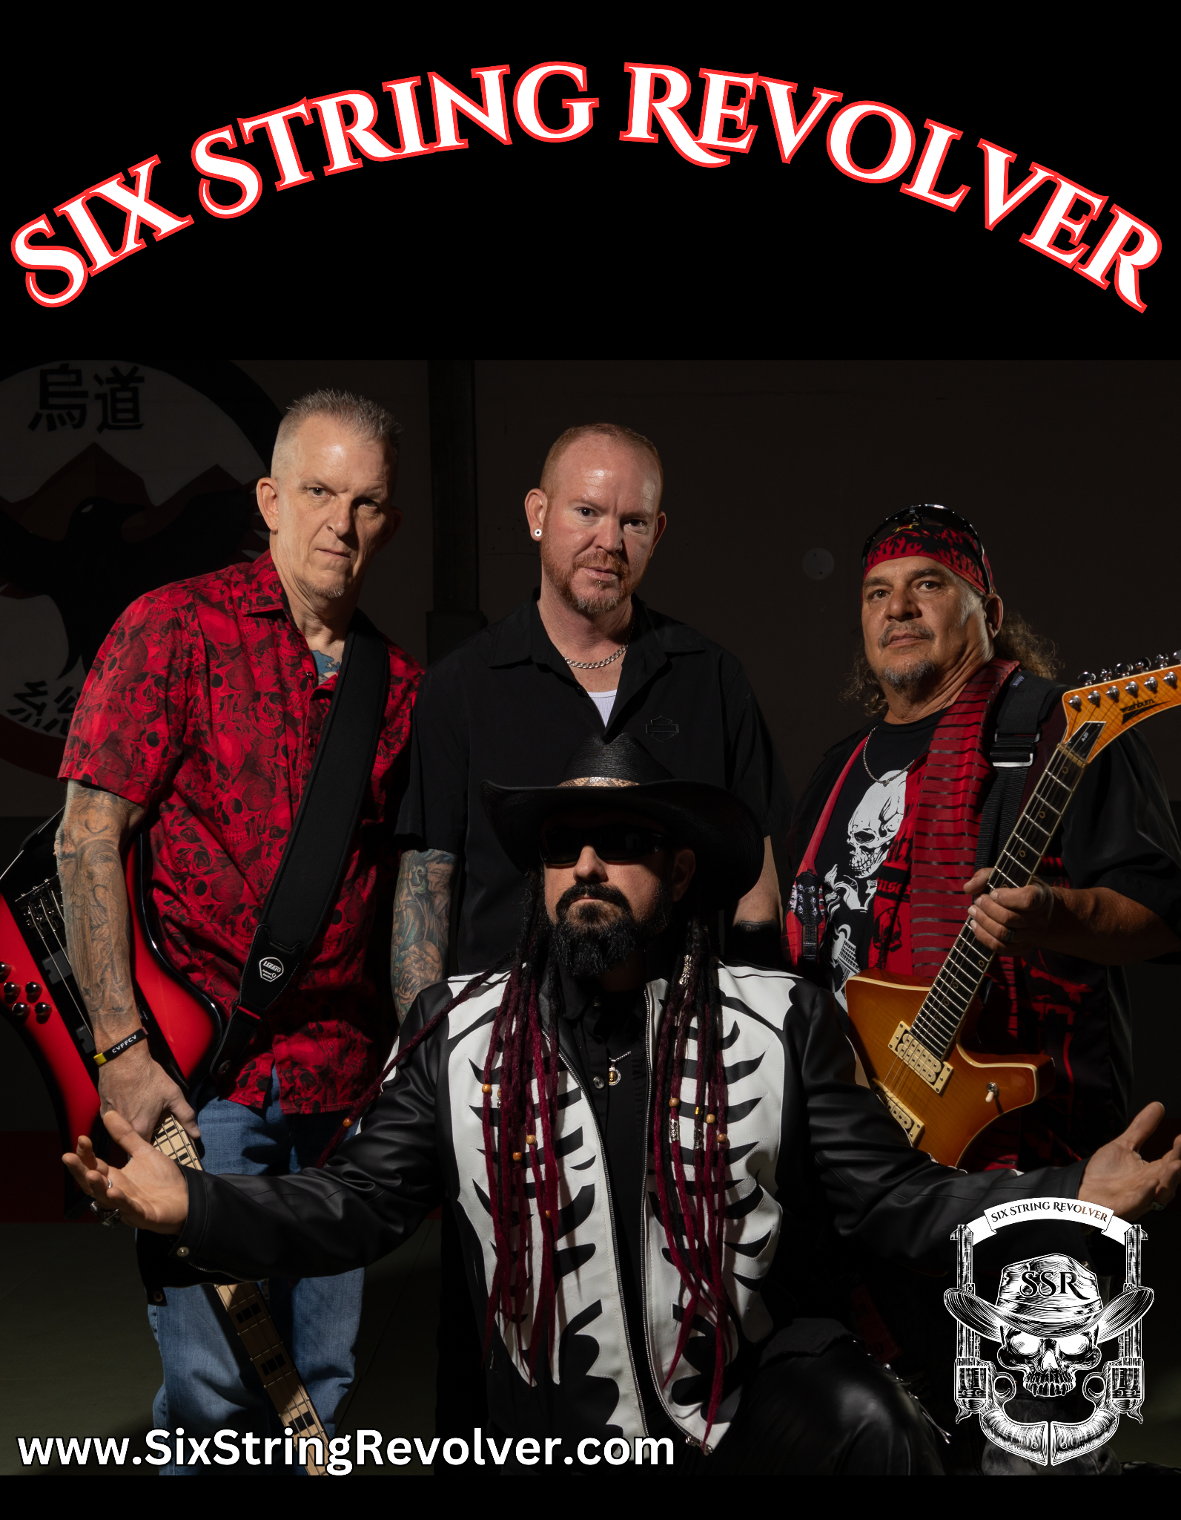

Six String Revolver Biography
Six String Revolver is an American Hard Rock band based out of the red mountains of Hurricane Utah, with a mission to bring original Rock music back into fashion. The band is a musical montage of some of the best players in the Southern Utah music scene. This local Super Group features on lead vocals Raven Cain, who has been on major recording labels such as Universal Music Group and is the subject of books, T.V. shows, and educational films. He has had multiple songs go to #1 on the 365 music charts. He has been a touring musician and has opened up for world-famous acts such as Henry Rollins, LA Guns, Sevendust, Bullet Boys, and Ratt, to name but a few.
On Lead Guitar is Hawkeye Pearce, a well-known musician, and virtuoso known for his technical playing, inspiring solos, and dynamic stage presence. Hawkeye is a veteran musician opening for iconic bands such as Alice Cooper, Great White, Sammy Hagar, Rick Derringer, Trixter, Nazareth, and Alabama. Hawkeye walked the red carpet at the famed VRMA’s with his band, who was nominated as the best entertainers in Las Vegas. According to Raven, Hawkeye is one of the greatest guitarists he has ever had the privilege of sharing the stage with.
Another legendary figure in the local music scene is Bassist Chuck Triplett, known for his solid melodic bass lines and hypnotic stage performance. Chuck has had the opportunity to open for notable acts such as Trapted, Royal Bliss, Aura Surreal, Count 77, American Hitmen, and many others in his illustrious career. It is widely known that anyone who sees Chuck play live gets a special treat; he is not your average boring Bass Player. To say his stage presence is hypnotic is truly an understatement.
On the drums is Mr. Dave Durfee, another local legend. Dave has toured worldwide, including playing drums in the middle of a warzone in Iraq. Among his many accomplishments would include opening for many well-known and famous acts such as Rob Zombie, Black Label Society, Godsmack, Poison, and Korn, to name a small list of the many he has shared the stage with. Dave is the band's backbone, keeping the grove and often laying down trance-like rhythms that somehow pull together the controlled chaos that is Six String Revolver.
The band initially came together as the brainchild of singer and songwriter Raven Cain and drummer Dave Durfee; after trying several Guitarists that did not vibe with the band, Raven, with Chuck's suggestion, brought in the talents of their long-time friend and Raven’s former bandmate Hawkeye Pearce. A band only works if the member's vibe, and what we have with Six String Revolver is a band of long-time friends. The audience can feel the band vibing within the first few notes. The four journeymen musicians comprise the energetic, charismatic, and immensely entertaining Six String Revolver.

Raven Cain - Lead Vocalist
Raven Cain's journey from a troubled past being raised in a doomsday cult to becoming a captivating and unconventional figure in the music industry is nothing short of extraordinary. Despite the challenges he faced early in life, Raven's determination and resilience propelled him towards a remarkable transformation.
Raven has gained considerable acclaim for his musical abilities. Currently, he is known as the charismatic and eccentric lead vocalist in Six String Revolver. However, he has previously partnered with renowned record labels such as Universal Music Group, solidifying his standing in the music industry. His individual discography consists of an impressive collection of five albums, each highlighting his adaptability and artistic development. Raven's introspective lyrics and heartfelt vocals, influenced by southern rock's bluesy and soulful sounds, have struck a chord with audiences, resulting in numerous chart-topping successes on the 365 music charts.
As a touring musician, Raven has had the privilege of sharing the stage with legendary acts such as Henry Rollins, LA Guns, Sevendust, Bullet Boys, and Ratt, among others. These experiences have allowed him to learn from the best and exposed him to diverse audiences, further expanding his fan base.
Raven's talents extend beyond music, as he has also made a name for himself in Martial Arts, literature, TV shows, and educational documentaries. His unique perspective and philosophical insights have been sought after by various media outlets, leading to appearances and collaborations that have further solidified his status as a captivating and unconventional figure.
Hawkeye Pearce - Lead Guitarist
Hawkeye Pearce is a well-known musician and virtuoso known for his technical playing, inspiring solos, and dynamic stage presence. Hawkeye is a veteran musician opening for iconic bands such as Alice Cooper, Great White, Sammy Hagar, Rick Derringer, Trixter, Nazareth, and Alabama. Hawkeye walked the red carpet at the famed VRMA’s with his band, who was nominated as the best entertainers in Las Vegas. According to Raven, Hawkeye is one of the greatest guitarists he has ever had the privilege of sharing the stage with.
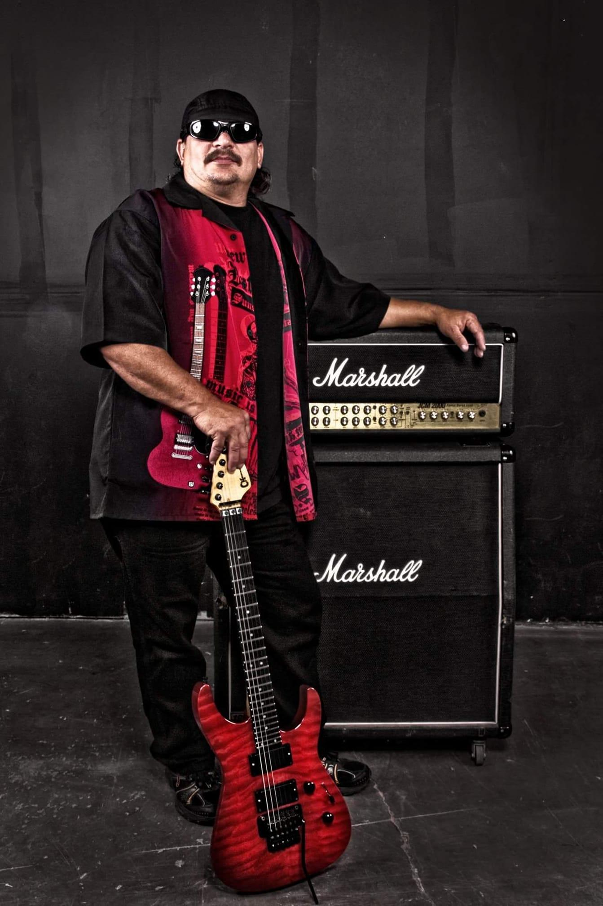

Chuck “Monkey” Triplett - Bassist
Monkey is a trailblazer in the music industry in Cedar City, UT. Some argue that without his consistent influence, there would be no music scene at all in Cedar. With his captivating bass runs and his extravagant stage presence, it is no surprise that he became associated with the SSR crowd.
Monkey has been a Veteran of the Southern Utah Music scene for over 25 years with multiple bands, both original and cover bands. Has released 10 albums that are officially available on Spotify. Bottled Monkey (5), Full Tilt Boogie (2), Swift and Sons, Mountain Top Sound and Masons Jar of Jam.
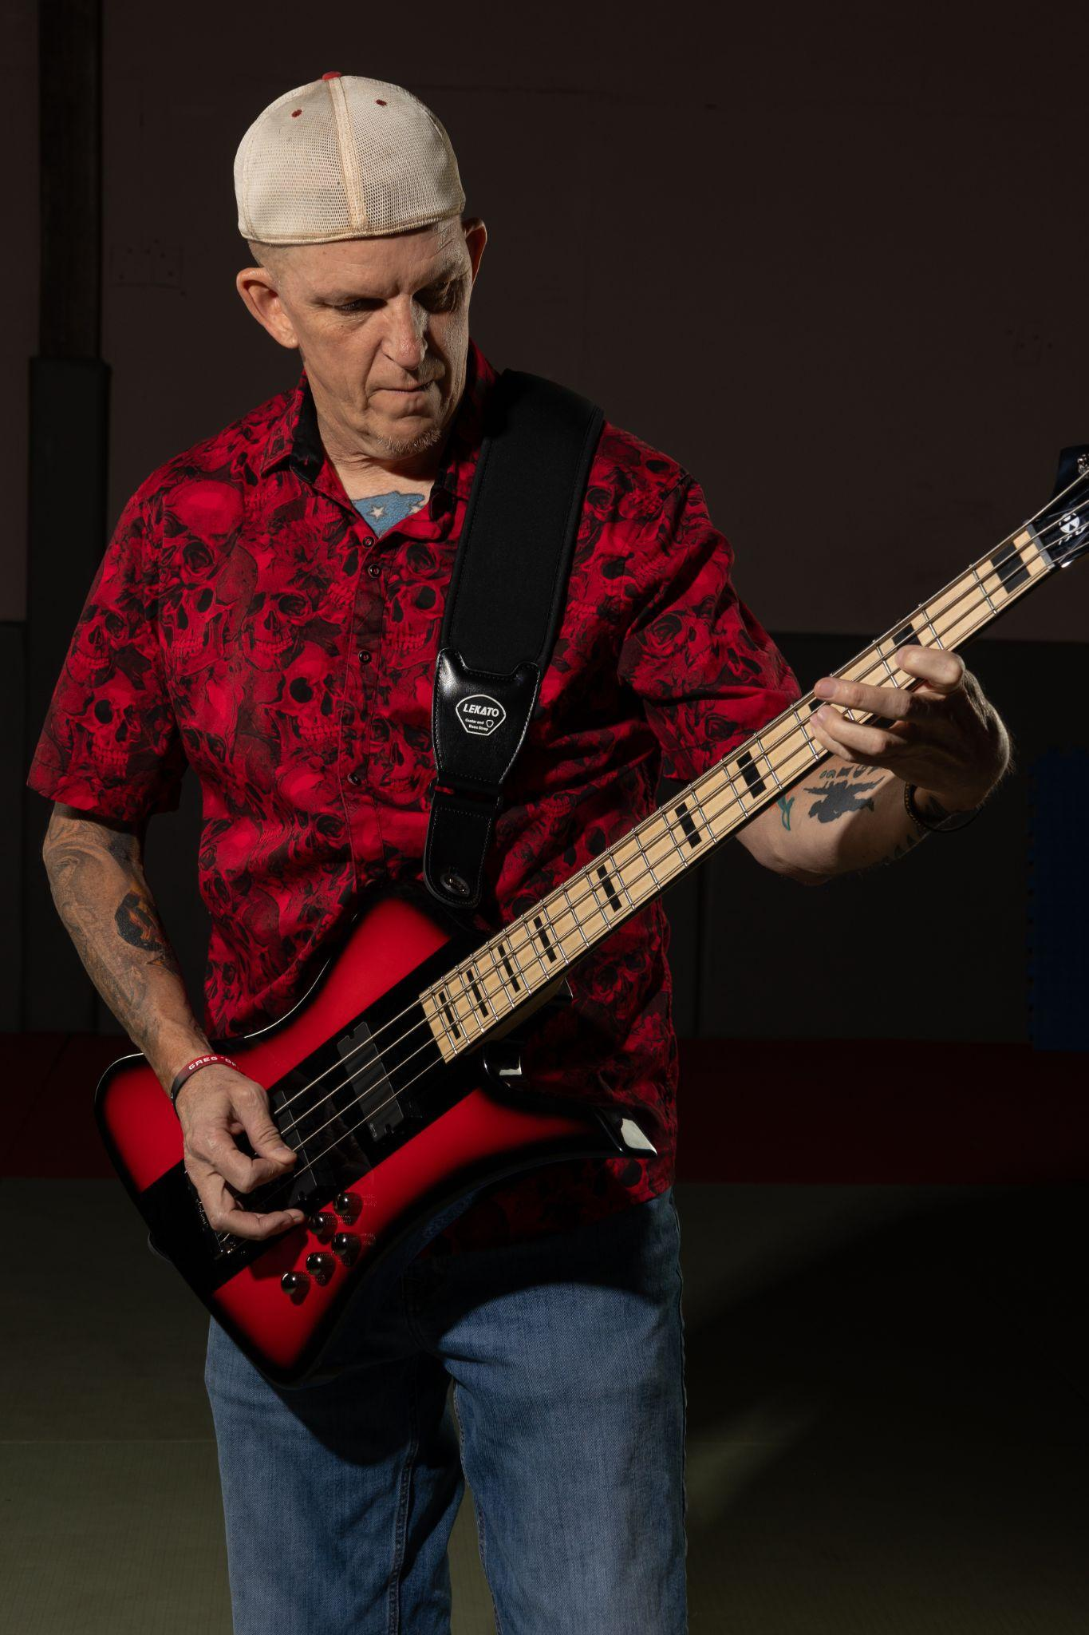
Monkey is a retired 25-year military vet and retired 20-year police vet and currently lives in Cedar City with his wife of over 30 years, Sandra.

Dave Durfee - Drums and Percussions

Dave Durfee, Drums, is a Veteran Musician. Part of the Power Trio ‘The Ensemble’ & ‘The Western Bone Cleavers’, as well as a founding member of ‘Aura Surreal’.
Dave has toured all over the Country and played for the ‘Duke Michael’s Band’ from Palm Springs, California, entertaining the Troops in Bosnia, Kosovo, Germany, Austria, Kuwait, Iraq & South Korea.
Dave has been playing with Raven over the last three years & is happy the stars aligned to be playing with Chuck after all these years.
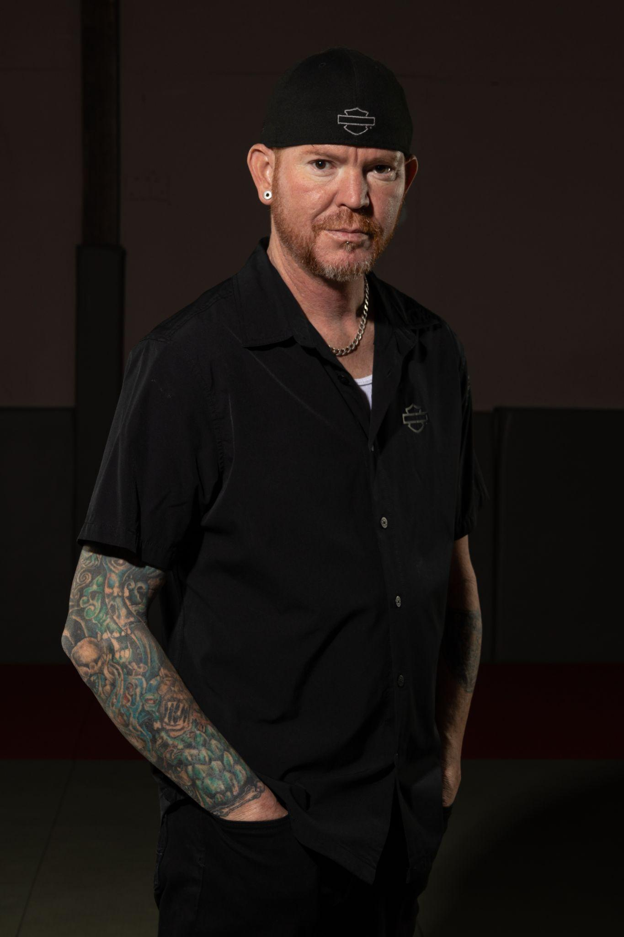

Media Quotes

“RAVEN CAIN could contribute to the soundtrack to "Sons Of Anarchy" all alone” Björn Backes - Power Metal.DE
“Raven hits home with his lyrics like a pulpit preacher man whippin’ up a storm.” SHAN SIVA - Battle Helm
" Raven is a talented guy who knows his craft inside out, and if this sort of rocking is your thing, then you’ll find it whiskey coated spades right here". Reviews Round Up
"The vocals reminded me of early Geoff Tate and Myles Kennedy such was the power and passion." CHRIS STONES - Down The Front Media
" I think I'll add this to my collection for those rainy Saturday afternoons when you just want to curl up with some great music and a hot toddy." MARIA GLOVER - Down The Front Media
“There is a real come back for this type of sound at the moment within the UK, well this is the real deal guys, not a kid from England.” Down The Front Media
“One of the only artists to get a major recording contract coming out of Southern Utah” Lee Gilbert - The Desert Pulse
“There is definitely a sound and feel when you sing and an energy when you perform.” GS - The Desert Pulse
"The intensity provided a nearly combustible feel to the "Church of Rock" as Raven calls the show." George Scott - The Independent
“Those that get the opportunity to hear and see him play will undoubtedly see he leaves nothing for reserve by the time he drags himself off the stage for the night--he puts every ounce of himself into the performance.” George Scott - Independent
"Raven reminds me of a blend of Hank Jr. and Axl Rose,” Dave Philpot of Flash Magazine said. “He has a certain grit to him that shows in his music, yet at the same time, there is tenderness and passion that you can really feel." The Independent

For Bookings, Media interviews and appearances, please contact
SixStringRevolverRocks@gmail.com
www.SixStringRevolver.com

804-665-4184
